Competency: Raizer II Emergency Lifting Chair
Date: | Address the Raizer is being used at:
Trainee Name:
Assessor Name:

Subject | Detail | Satisfactory competency level ()
Product | The Raizer is a battery-powered mobile lifting chair which helps a lying person up to an almost standing position in a few minutes. The Raizer can be operated by only a single assistant and requires no physical effort from the assistant aside from a helping hand.  The Raizer is simple to operate by means of the control panel mounted on the side of the seat, or with the remote control.  The Raizer should only be used to bring a person lying on the floor to a seated or almost standing position, if the person is unable to do so by him-/herself. The person may require relocation from this position.  The max. load of the Raizer is stated on the CE mark on the rear of the seat. The Raizer can be used approx. 40 times at full load on a full charge. A charger is included with your Raizer.
The controls | 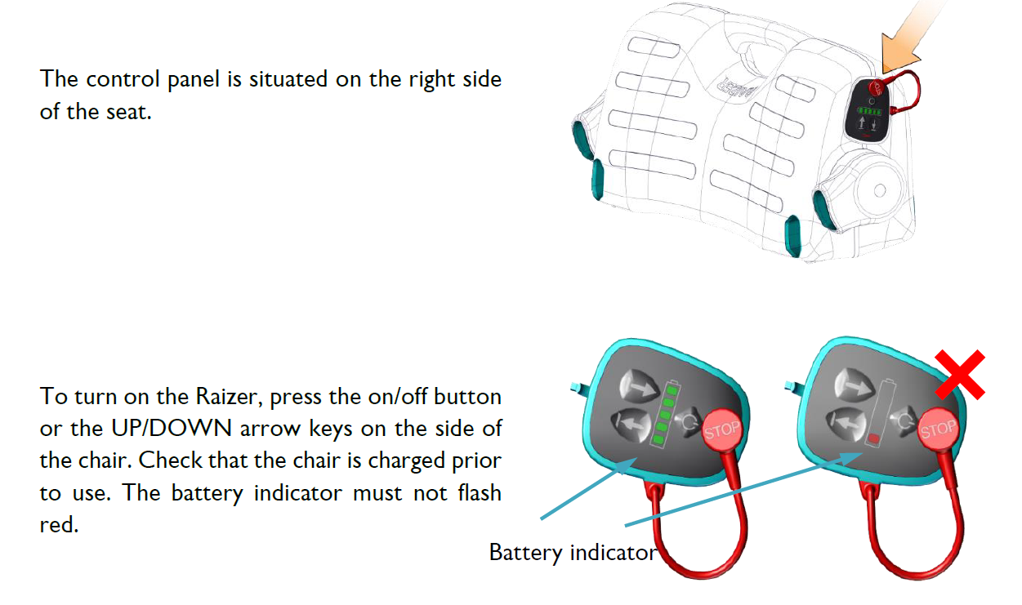  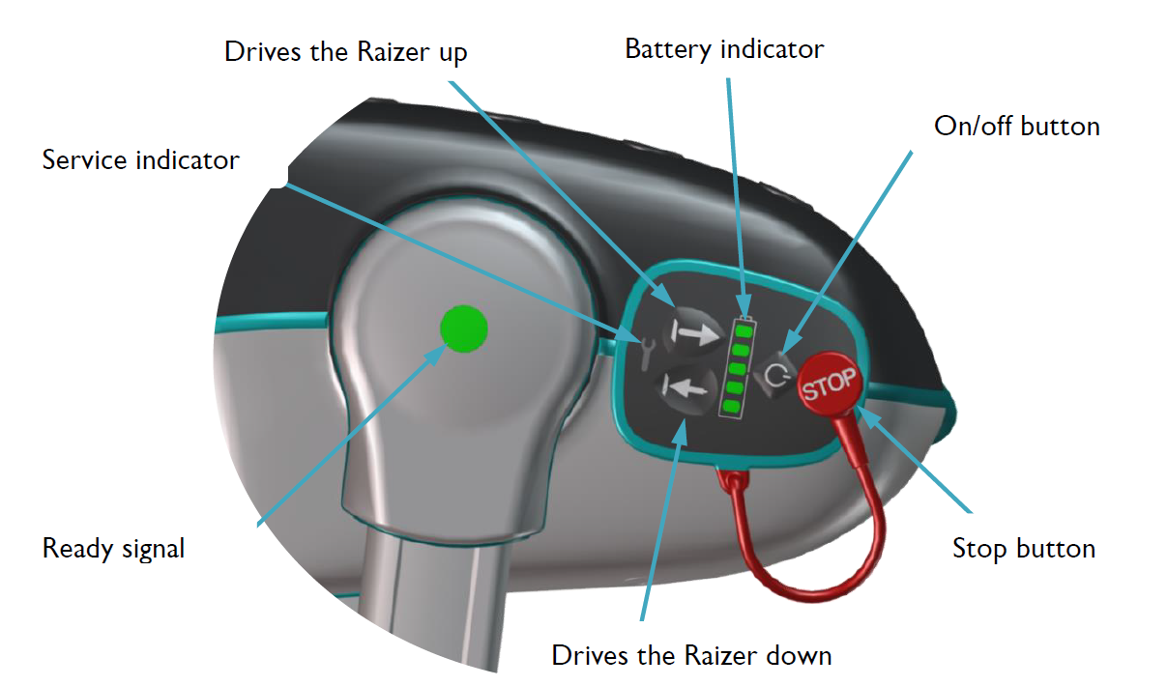
Operation | - The control panel is situated on the right side of the seat.  - To turn on the Raizer, press the on/off button or the UP/DOWN arrow keys on the side of the chair. Check that the chair is charged prior to use. The battery indicator must not flash red.  - The remote control is placed in a pocket on the side of the seat and fixed with a magnet. It is released with a light push to the upper part of the remote control.  - Approach the fallen person.  - Place the seat on the floor by the person's side.  - Lift the thighs to an angled position.  - Carefully push the seat in under the thighs.  - Backrest 1: Turn the person carefully by the shoulder, with a light push to the elbow. Push the backrest carefully under the shoulder of the person.  - Click the backrest into place in the seat with a sliding movement.  - If necessary, place your foot in front of the seat to stop it from slipping forward.  - A confirmation tone will sound, when the backrest has been correctly fitted ().  - Repeat the process for the other backrest.  - If the seat belt has not already been fitted on the backrest, mount it by pushing the fitting downwards over the backrest profile with a sliding movement. The fitting can be mounted from both ends.  - Fasten the seat belt. A distinct click will be heard.  - Insert all 4 legs, one at a time, until it clicks into place. A confirmation tone will sound when the leg has been correctly fitted ().  - When all 4 legs have been fitted correctly, a double confirmation tone will follow (). The double alert signifies that the Raizer is ready to lift a person.  - The LED light the side of the Raizer now changes from yellow to green to demonstrate that the Raizer is ready for operation.  - The Raizer is now ready to lift the person. Before initiating the lift, make sure that the person is ready, and give a warning that the lift will begin.  - Support the person’s neck with one hand. Press the UP arrow (↑) on the control panel or the remote control.  - Press the UP arrow (↑) until the person has reached the requested position.  - The Raizer will automatically stop when reaching its top position and the person is in an upright sitting position.  - The Raizer is safeguarded against running too high and therefore stops automatically in its top position. A confirmation tone will sound (), indicating that the Raizer has reached its top position.  NEVER push the Raizer when a person is sitting on it. The wheels of the legs are only meant to avoid scratches to the floor in connection with the lifting procedure.  Refer to the User Manual for diagrams.
Disassembly | - Run the Raizer into a horizontal position and disassemble.  - Do not forget to place the remote control in its pocket, as otherwise a vibrant warning tone will sound when all legs have been dis-mounted.  - Put all parts into the carrying bags.
Charging | - The battery indicator (LED) lights green when the battery is fully charged.  - The battery indicator (LED) flashes red to show that the battery capacity is below 10% and the Raizer must be recharged.  - The charger socket is situated in the same place as the red stop button.  - Remove the stop button and plug the charger cable into the socket. The plug is mounted with a magnet and will snap into place by itself.  - Connect the provided charger to the socket on the Raizer. (Or use the provided USB cable.)
Cleaning | The Raizer is not water-proof.  It is however acceptable to clean the Raizer with a damp cloth.  You can disinfect your Raizer using disinfectant sprays such as "Clinell".
Maintanence | The mechanical maintenance of the Raizer shall normally only be undertaken in connection with the regular annual service inspection. This is to be undertaken by a qualified service technician.
Troubleshooting | https://www.liftup.dk/en/products/accessories/raizer-video-guide/  